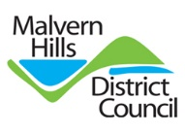
Malvern Hills Equalities and Diversity Profile

This profile provides an overview of the people who live in the Malvern Hills district. It includes demographic analysis, income and deprivation data. The data is taken from a range of sources including ONS, nomis and the census.
It is designed to give us and those we work with an understanding of our communities and to provide intelligence that helps inform strategic priority setting, decision making and planning of services to meet customers' needs.
We will update the profile at least once a year and add any further data that helps enhance our understanding of our communities and the outcomes and opportunities experienced by different groups of people. You can find out more information about the Malvern Hills district on the insight section of our website.

District Overview
Malvern Hills mid-2019 population
Age category | Population | Percentage
Under 18 | 14,301 | 18.2%
18-24 | 4,550 | 5.8%
25-34 | 6,890 | 8.8%
35-44 | 7,682 | 9.8%
45-54 | 11,225 | 14.3%
55-64 | 11,874 | 15.1%
65-74 | 22,176 | 28.2%
75+ | 10,645 | 13.5%
Total | 78,698

Ethnicity
2011 Census ethnicity %
White | 97.6
Mixed/multiple ethnic groups | 0.9
Asian/Asian British | 1.2
Black/African/Caribbean/Black British | 0.2
Other ethnic group | 0.1

Religion
2011 Religion %
Christian | 67.5
Buddhist | 0.3
Hindu | 0.1
Jewish | 0.1
Muslim | 0.3
Sikh | 0.1
Other religion | 0.5
No religion | 23.9
Religion not stated | 7.3

Disability
2011 Disability %
Day-to-day activities limited a lot | 8.7%
Day-to-day activities limited a little | 10.9%
Day-to-day activities not limited | 80.5%

Rural classification
Of the current population of Malvern Hills 40,823 live in rural areas which equates to 51.9% of the population.
Urban city and town | 37,875
Rural town and fringe | 8,338
Rural village and dispersed | 32,485
Total | 78,698

Employment
Employee jobs by industry | No. of jobs | % of jobs
B: Mining and quarrying | 35 | 0.1
C: Manufacturing | 4,000 | 13.8
D: Electricity, gas, steam and air conditioning supply | 5 | 0
E: Water supply; sewerage, waste management etc. | 125 | 0.4
F Construction | 1,500 | 5.2
G : Wholesale and retail trade; repair of motor vehicles | 4,000 | 13.8
H: Transportation and storage | 400 | 1.4
I: Accommodation and food service activities | 4,000 | 13.8
J: Information and communication | 800 | 2.8
K: Financial and insurance activities | 250 | 0.9
L: Real estate activities | 450 | 1.6
M: Professional, scientific and technical activities | 2,500 | 8.6
N: Administrative and support service activities | 2,000 | 6.9
O: Public administration and defence | 500 | 1.7
P: Education | 3,000 | 10.3
Q: Human health and social work activities | 3,500 | 12.1
R: Arts, entertainment and recreation | 700 | 2.4
S: Other service activities | 1,500 | 5.2

Workforce comparison
Malvern Hills has a workforce that is made up of more male than female workers. There is a greater proportion of workers aged 45-54 than the population of the district and an under-representation of those aged 55-64.

Deprivation
The Indices of Multiple Deprivation measures of relative deprivation at a small local area level (Lower-layer Super Output Areas) across England

They provide a set of relative measures of deprivation for small areas across England, based on seven different domains, or facets, of deprivation:

• Income Deprivation
• Employment Deprivation
• Education, Skills and Training Deprivation
• Health Deprivation and Disability
• Crime
• Barriers to Housing and Services
• Living Environment Deprivation

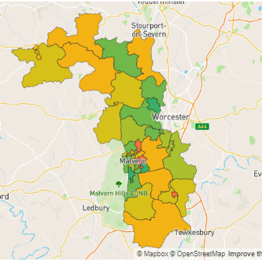
Overall Indices of Multiple Deprivation 2019
All of these domains combine to create an overall measure of deprivation. One of the 45 neighbourhoods (LSOA’s) in Malvern Hills falls into the most deprived 10% nationally (Sherrard’s Green, Pickersleigh) and in the second most deprived decile (Orford Way, Pickersleigh).
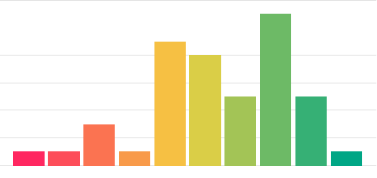

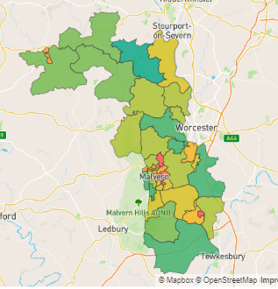
Employment domain
Each of the domains are also looked at separately and for the employment domain there are five neighbourhoods in the most deprived 205 nationally.
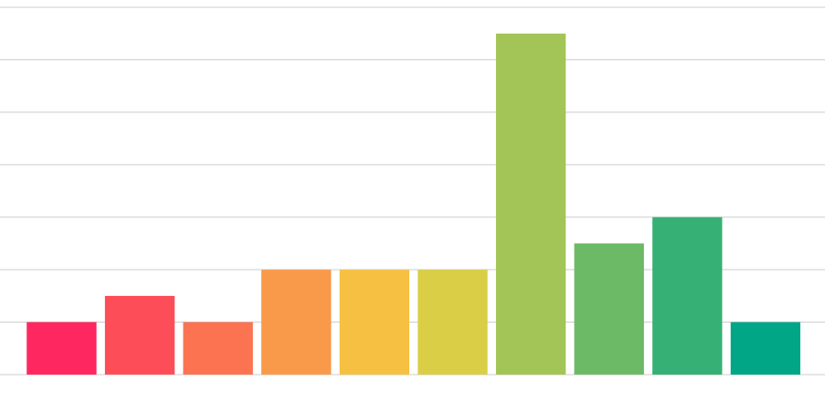

Vulnerability maps

Single pensioners
The map below represents the population of those aged 65+ that live alone in the district.

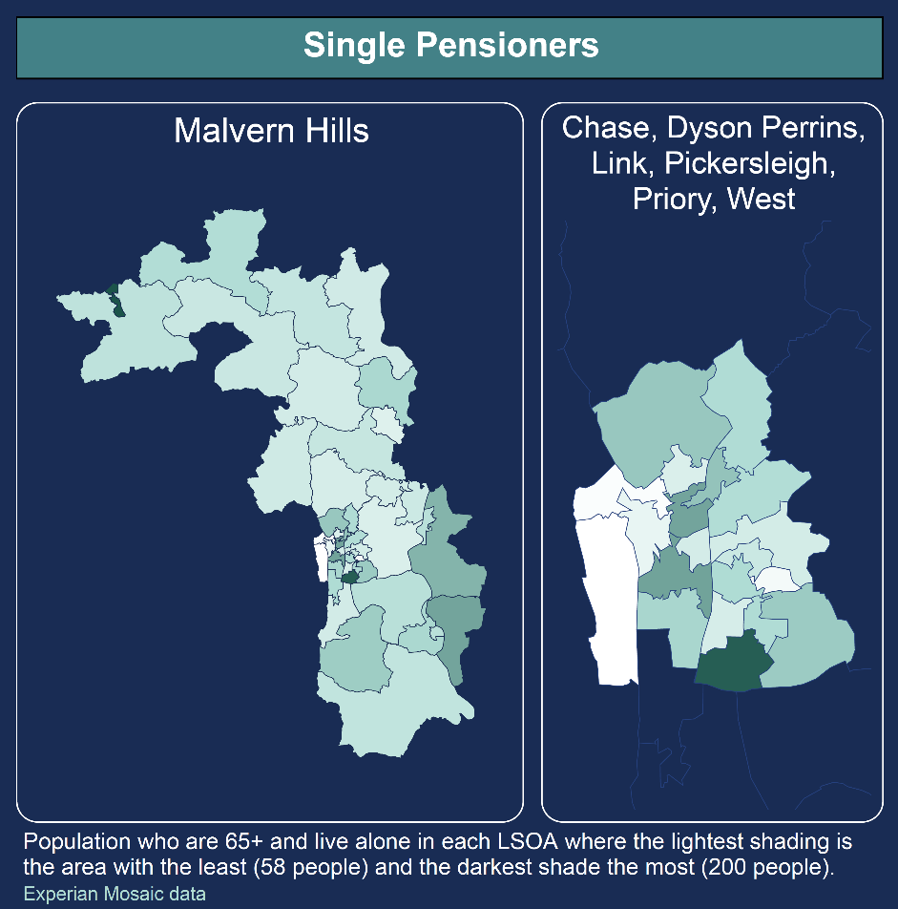

Income Deprivation
This map was produced using IMD 2019 income deprivation data which measures the proportion of the population experiencing deprivation relating to low income. The definition of low income used includes both those people that are out-of-work, and those that are in work but who have low earnings.
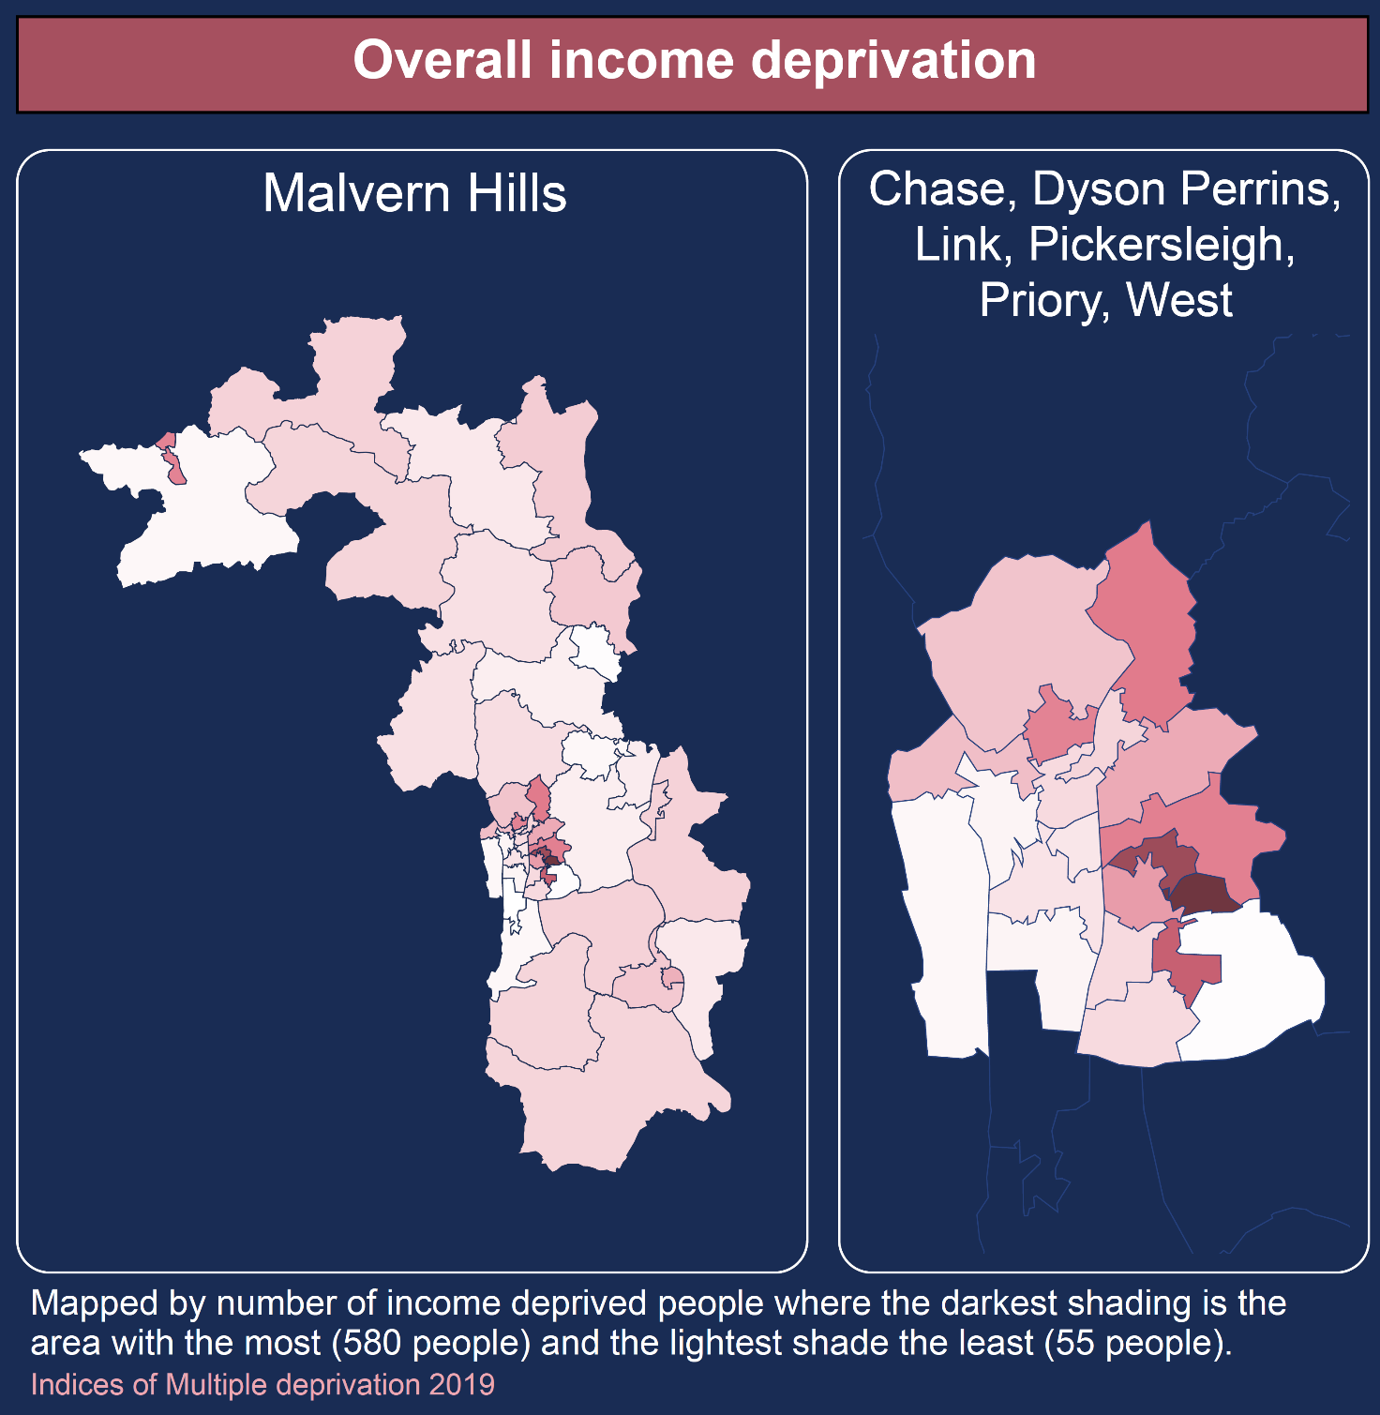

Income Deprivation Affecting Children Index
This map represents a supplementary index of the income deprivation affecting children and measures the proportion of all children aged 0 to 15 living in income deprived families
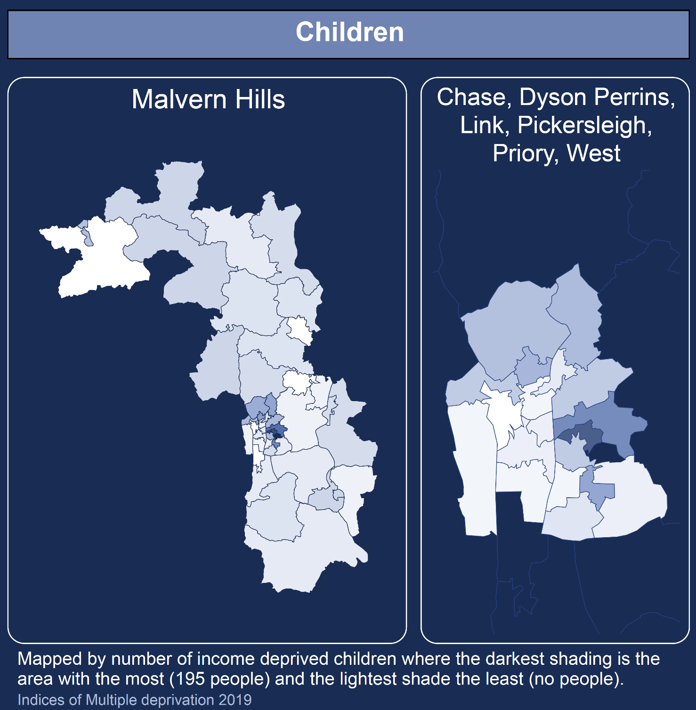

Income Deprivation Affecting Older People Index
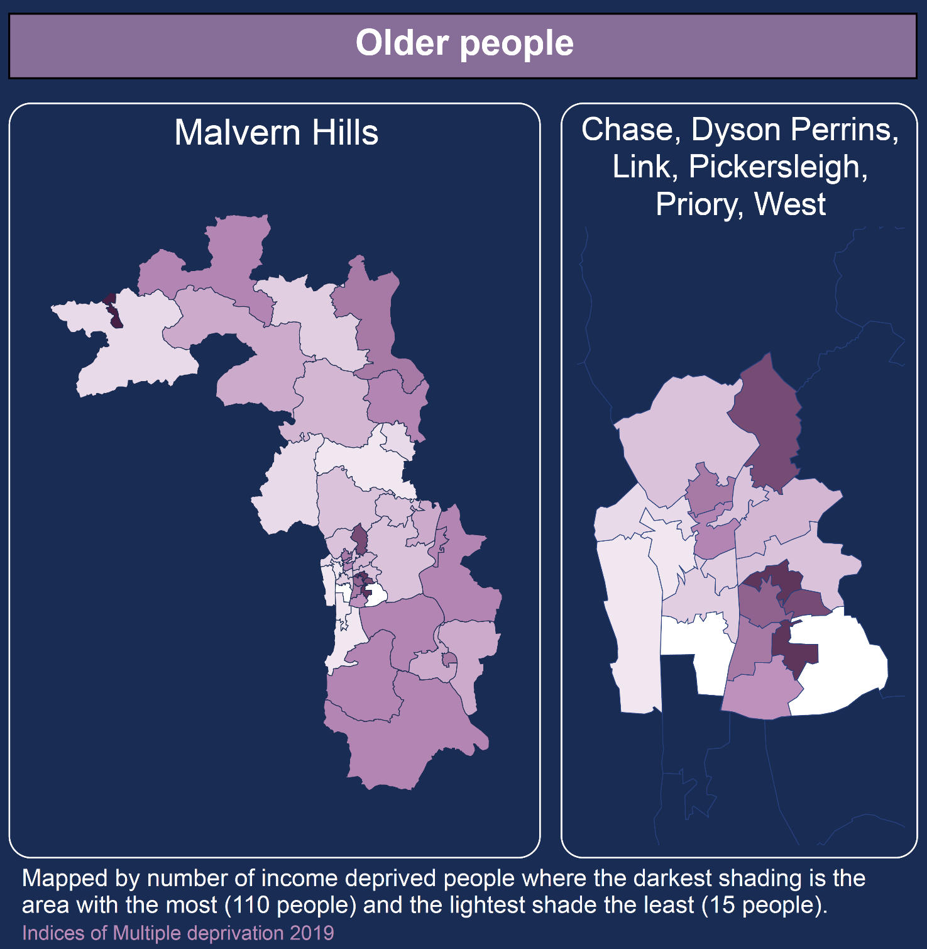
This map represents the second supplementary index of the income deprivation domain and measures the proportion of all those aged 60 or over who experience income deprivation.

